Tangent–Chord Theorem
# Source: AI Source: Provided by: [Data Path: Persons Table -> ID Column: 1, Name_En Column: Motasem Essam] -> From: [ChatGPT] on [7/25/2026]
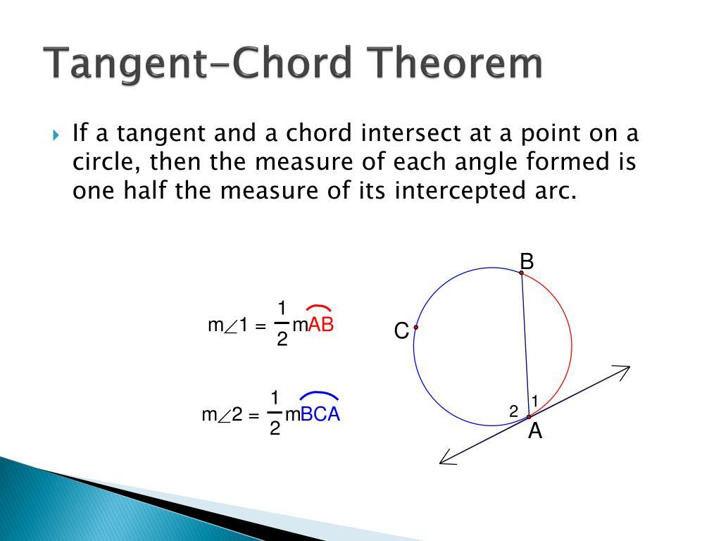
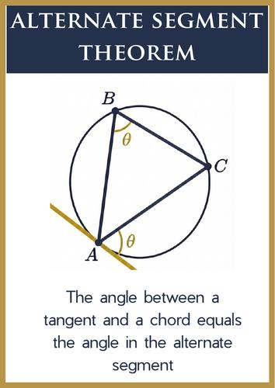
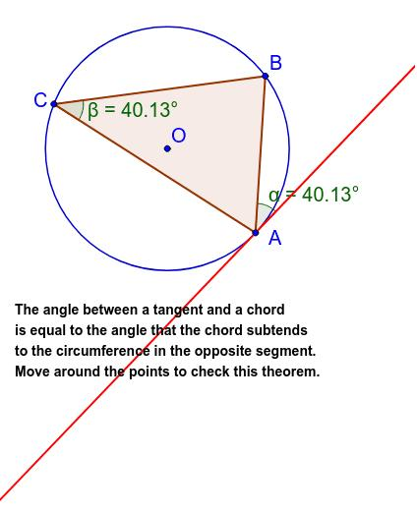
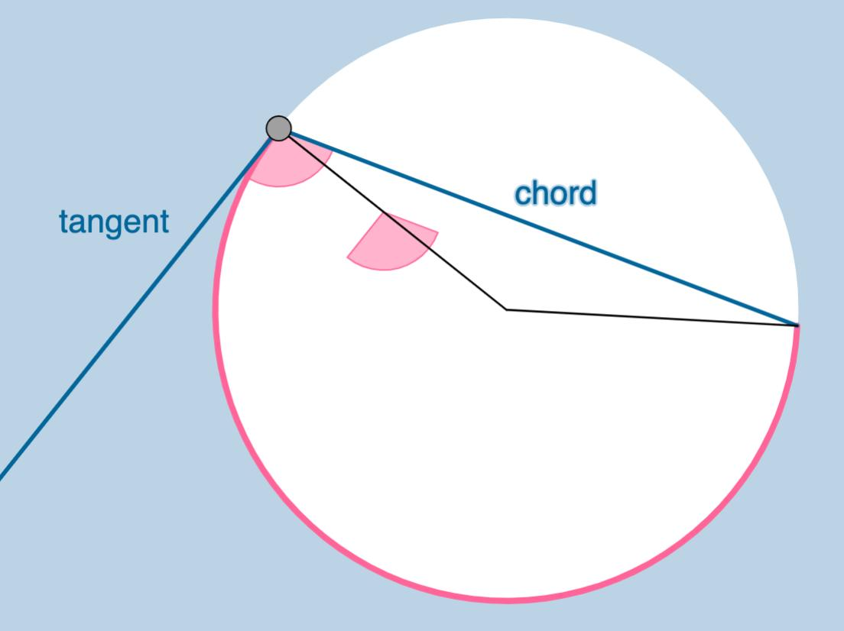
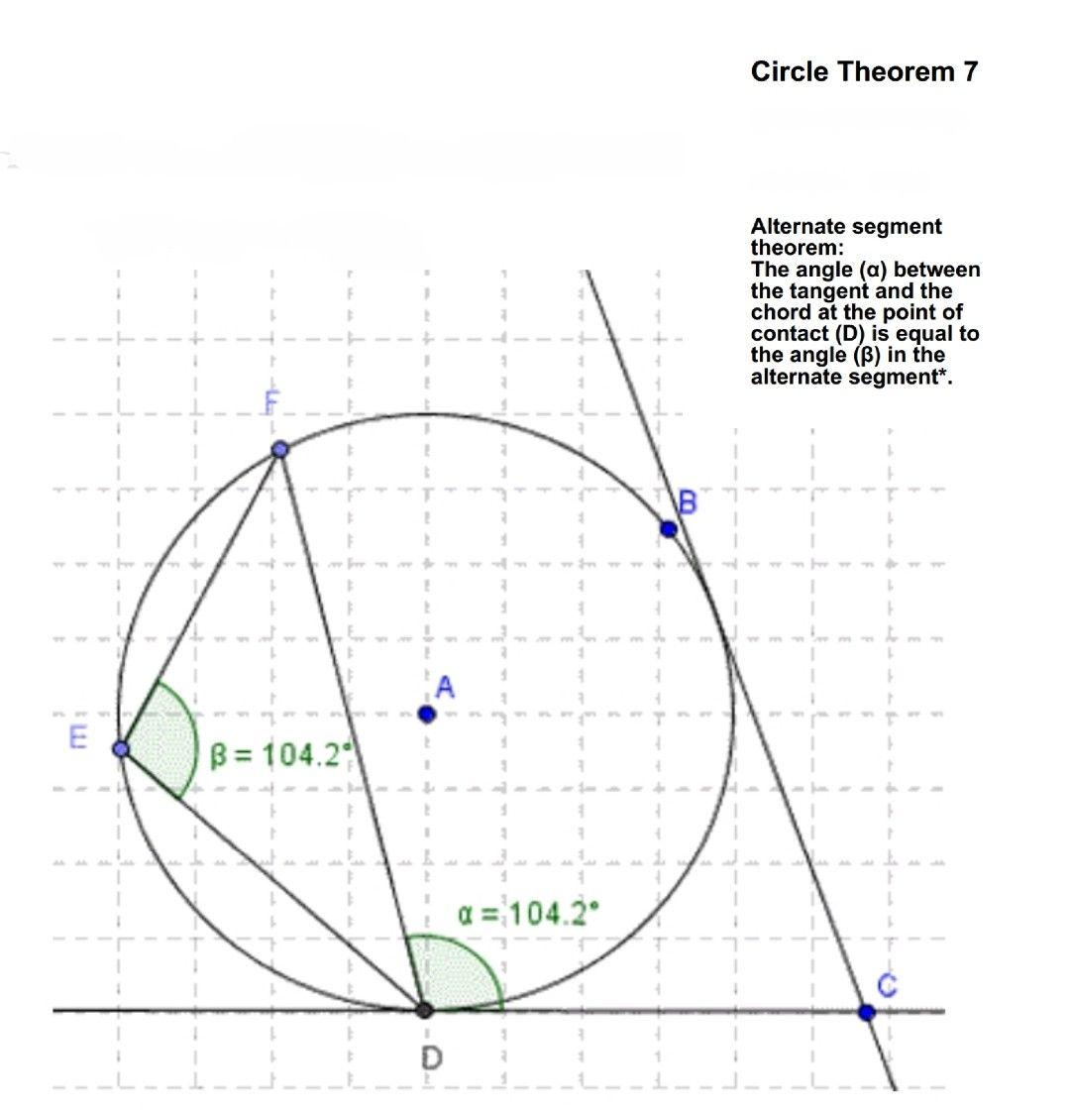

Definition
# Source: AI Source: Provided by: [Data Path: Persons Table -> ID Column: 1, Name_En Column: Motasem Essam] -> From: [ChatGPT] on [7/25/2026]
The Tangent–Chord Theorem states that:
The angle between a tangent to a circle and a chord through the point of tangency is equal to the angle in the alternate segment subtended by that chord.
If a tangent touches a circle at $A$, and $AB$is a chord, then the angle between the tangent and chord $AB$equals the inscribed angle subtended by chord $AB$in the opposite segment of the circle.
For example:
$$\boxed{m\left(∠TAB\right)=m\left(∠ACB\right)}$$
where:
- $TA$is tangent to the circle at $A$,
- $AB$is a chord,
- $C$is a point on the opposite arc.
This theorem is also called the Alternate Segment Theorem.

Fundamental Concept
# Source: AI Source: Provided by: [Data Path: Persons Table -> ID Column: 1, Name_En Column: Motasem Essam] -> From: [ChatGPT] on [7/25/2026]
Consider a circle with:
- tangent $TA$touching the circle at $A$,
- chord $AB$,
- point $C$on the opposite arc.
Then:
$$\boxed{∠TAB=∠ACB}$$
The angle between the tangent and the chord is therefore equal to an inscribed angle standing on the same chord.
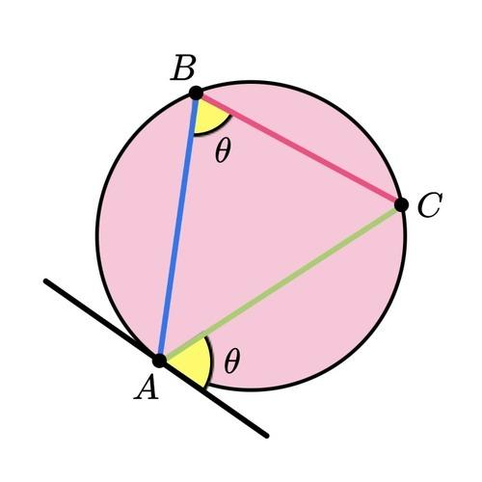
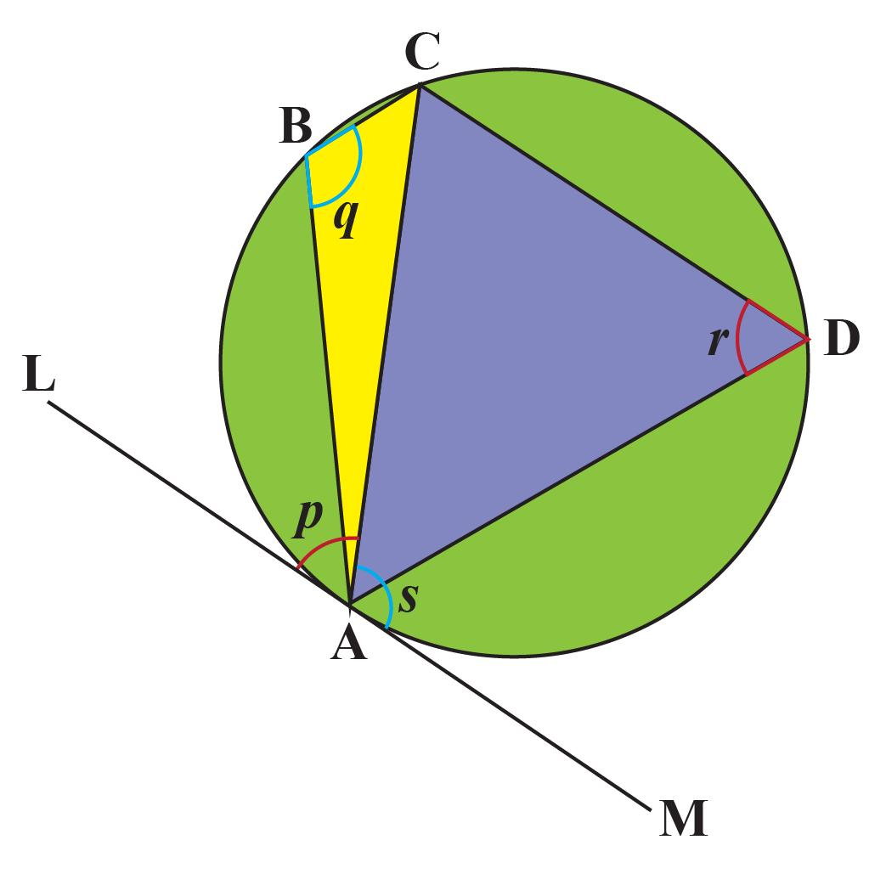
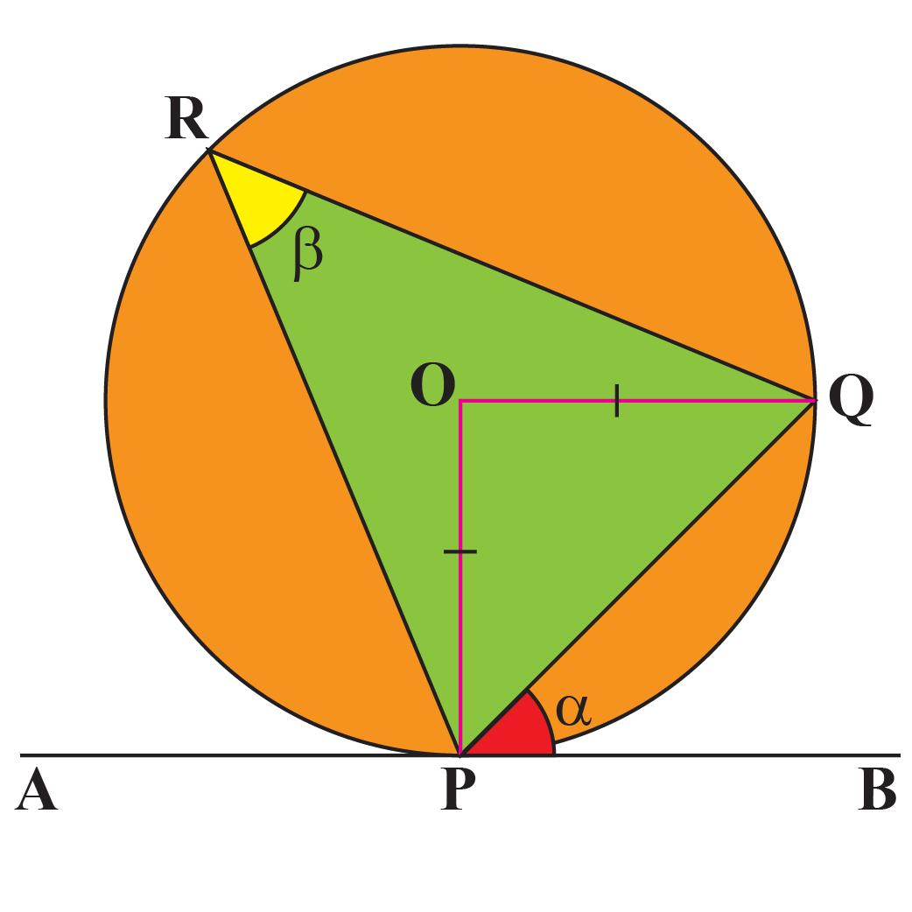
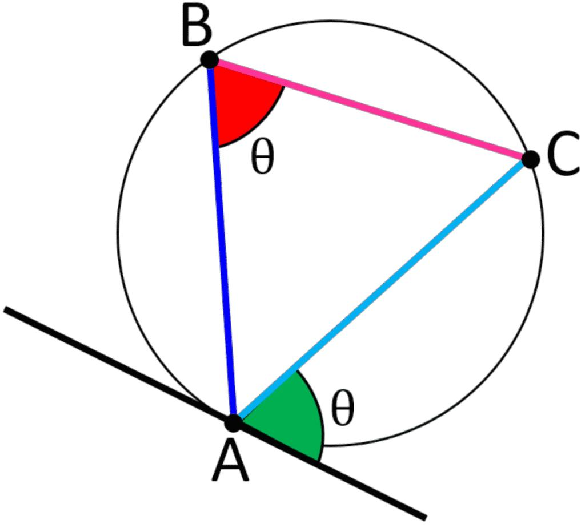

Main Parts
# Source: AI Source: Provided by: [Data Path: Persons Table -> ID Column: 1, Name_En Column: Motasem Essam] -> From: [ChatGPT] on [7/25/2026]
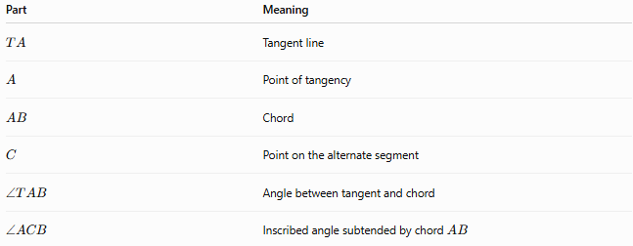
Part | Meaning
$$TA$$ | Tangent line
$$A$$ | Point of tangency
$$AB$$ | Chord
$$C$$ | Point on the alternate segment
$$∠TAB$$ | Angle between tangent and chord
$$∠ACB$$ | Inscribed angle subtended by chord $AB$
The essential relationship is:
$$\boxed{∠TAB=∠ACB}$$

Theorem Statement
# Source: AI Source: Provided by: [Data Path: Persons Table -> ID Column: 1, Name_En Column: Motasem Essam] -> From: [ChatGPT] on [7/25/2026]
If a tangent touches a circle at $A$, and $AB$is a chord, then:
$$\boxed{\text{Angle between tangent and chord}=\text{angle in the alternate segment}}$$
In symbols:
$$\boxed{m\left(∠TAB\right)=m\left(∠ACB\right)}$$

Why It Works
# Source: AI Source: Provided by: [Data Path: Persons Table -> ID Column: 1, Name_En Column: Motasem Essam] -> From: [ChatGPT] on [7/25/2026]
The tangent–chord angle is related to the central angle subtended by the chord.
Suppose $O$is the center.
The central angle corresponding to chord $AB$is:
$$∠AOB$$
The inscribed angle subtending the same chord is:
$$∠ACB$$
By the Inscribed Angle Theorem:
$$m\left(∠ACB\right)=\frac{1}{2}m\left(∠AOB\right)$$
The radius $OA$is perpendicular to the tangent:
$$OA⊥TA$$
Therefore, the angle between the tangent and chord is also half the appropriate central-angle measure.
Thus:
$$\boxed{m\left(∠TAB\right)=m\left(∠ACB\right)}$$

Relationship with the Inscribed Angle Theorem
# Source: AI Source: Provided by: [Data Path: Persons Table -> ID Column: 1, Name_En Column: Motasem Essam] -> From: [ChatGPT] on [7/25/2026]
The Tangent–Chord Theorem is closely related to the Inscribed Angle Theorem.
Inscribed Angle Theorem
$$\boxed{m\left(\text{inscribed angle}\right)=\frac{1}{2}m\left(\text{intercepted arc}\right)}$$

Tangent–Chord Theorem
# Source: AI Source: Provided by: [Data Path: Persons Table -> ID Column: 1, Name_En Column: Motasem Essam] -> From: [ChatGPT] on [7/25/2026]
$$\boxed{m\left(\text{tangent–chord angle}\right)=m\left(\text{inscribed angle standing on the same chord}\right)}$$
Therefore:
$$\boxed{m\left(∠TAB\right)=\frac{1}{2}m\left(\hat{AB}\right)}$$
for the appropriate intercepted arc.

Relationship with the Central Angle
# Source: AI Source: Provided by: [Data Path: Persons Table -> ID Column: 1, Name_En Column: Motasem Essam] -> From: [ChatGPT] on [7/25/2026]
For the same chord $AB$:
$$m\left(∠AOB\right)=m\left(\hat{AB}\right)$$
and:
$$m\left(∠ACB\right)=\frac{1}{2}m\left(\hat{AB}\right)$$
Therefore:
$$\boxed{m\left(∠ACB\right)=\frac{1}{2}m\left(∠AOB\right)}$$
The tangent–chord angle has the same measure:
$$\boxed{m\left(∠TAB\right)=\frac{1}{2}m\left(∠AOB\right)}$$
Hence:
$$\boxed{m\left(∠TAB\right)=m\left(∠ACB\right)=\frac{1}{2}m\left(∠AOB\right)}$$

Example 1 — Direct Application
# Source: AI Source: Provided by: [Data Path: Persons Table -> ID Column: 1, Name_En Column: Motasem Essam] -> From: [ChatGPT] on [7/25/2026]
Suppose the angle between tangent $TA$and chord $AB$is:
$${50}^{∘}$$
Then the angle in the alternate segment is:
$$\boxed{∠ACB={50}^{∘}}$$
because:
$$∠TAB=∠ACB$$

Example 2 — Finding the Tangent–Chord Angle
# Source: AI Source: Provided by: [Data Path: Persons Table -> ID Column: 1, Name_En Column: Motasem Essam] -> From: [ChatGPT] on [7/25/2026]
Suppose an inscribed angle subtended by chord $AB$is:
$${35}^{∘}$$
Then:
$$∠TAB={35}^{∘}$$
Therefore:
$$\boxed{∠TAB={35}^{∘}}$$

Example 3 — Using the Arc
# Source: AI Source: Provided by: [Data Path: Persons Table -> ID Column: 1, Name_En Column: Motasem Essam] -> From: [ChatGPT] on [7/25/2026]
Suppose chord $AB$subtends an arc of:
$${120}^{∘}$$
The inscribed angle is:
$$\frac{{120}^{∘}}{2}={60}^{∘}$$
Therefore, by the Tangent–Chord Theorem:
$$\boxed{∠TAB={60}^{∘}}$$

Example 4 — Using the Central Angle
# Source: AI Source: Provided by: [Data Path: Persons Table -> ID Column: 1, Name_En Column: Motasem Essam] -> From: [ChatGPT] on [7/25/2026]
Suppose:
$$m\left(∠AOB\right)={140}^{∘}$$
Then the inscribed angle subtending chord $AB$is:
$$\frac{{140}^{∘}}{2}={70}^{∘}$$
Therefore:
$$\boxed{m\left(∠TAB\right)={70}^{∘}}$$

Two Tangent–Chord Angles
# Source: AI Source: Provided by: [Data Path: Persons Table -> ID Column: 1, Name_En Column: Motasem Essam] -> From: [ChatGPT] on [7/25/2026]
A chord has two possible angles with a tangent line, depending on which ray of the tangent and which side of the chord is considered.
The corresponding inscribed angles may involve the minor arc or major arc.
For a chord $AB$:
$$m\left(\text{minor arc }AB\right)+m\left(\text{major arc }AB\right)={360}^{∘}$$
Therefore, the corresponding inscribed angles satisfy:
$$\frac{1}{2}m\left(\text{minor arc}\right)+\frac{1}{2}m\left(\text{major arc}\right)={180}^{∘}$$
Thus, the two corresponding angles are supplementary:
$$\boxed{θ_{1}+θ_{2}={180}^{∘}}$$
when they are the two angles formed using the appropriate opposite segments.

Special Case: Tangent and Diameter
# Source: AI Source: Provided by: [Data Path: Persons Table -> ID Column: 1, Name_En Column: Motasem Essam] -> From: [ChatGPT] on [7/25/2026]
If the chord is actually a diameter, the tangent–chord angle is:
$${90}^{∘}$$
because a tangent is perpendicular to the radius at the point of tangency, and a diameter passes through the center.
Thus:
$$\boxed{\text{Tangent}⊥\text{Diameter}}$$
This is consistent with the theorem because a diameter subtends a semicircle:
$$m\left(\text{semicircle}\right)={180}^{∘}$$
and therefore:
$$\frac{1}{2}\left({180}^{∘}\right)={90}^{∘}$$

Proof Using the Center
# Source: AI Source: Provided by: [Data Path: Persons Table -> ID Column: 1, Name_En Column: Motasem Essam] -> From: [ChatGPT] on [7/25/2026]
Let:
- $O$be the center,
- $TA$be tangent at $A$,
- $AB$be a chord,
- $C$be a point on the alternate segment.
Since $OA$is a radius to the point of tangency:
$$OA⊥TA$$
Therefore:
$$∠OAT={90}^{∘}$$
Let:
$$m\left(∠AOB\right)=2θ$$
Since $OA=OB$, triangle $AOB$is isosceles.
Thus:
$$m\left(∠OAB\right)=\frac{{180}^{∘}-2θ}{2}={90}^{∘}-θ$$
Therefore:
$$m\left(∠TAB\right)={90}^{∘}-m\left(∠OAB\right) \\ ={90}^{∘}-\left({90}^{∘}-θ\right) \\ =θ$$
By the Inscribed Angle Theorem:
$$m\left(∠ACB\right)=\frac{1}{2}m\left(∠AOB\right) \\ =\frac{1}{2}\left(2θ\right) \\ =θ$$
Therefore:
$$\boxed{∠TAB=∠ACB}$$
which proves the Tangent–Chord Theorem.

Converse of the Theorem
# Source: AI Source: Provided by: [Data Path: Persons Table -> ID Column: 1, Name_En Column: Motasem Essam] -> From: [ChatGPT] on [7/25/2026]
The converse can also be used:
If the angle between a line and a chord equals the angle subtended by the chord in the alternate segment, then the line is tangent to the circle at the endpoint of the chord.
In practical geometry problems, this can help prove that a line is tangent to a circle.

Important Relationships
# Source: AI Source: Provided by: [Data Path: Persons Table -> ID Column: 1, Name_En Column: Motasem Essam] -> From: [ChatGPT] on [7/25/2026]
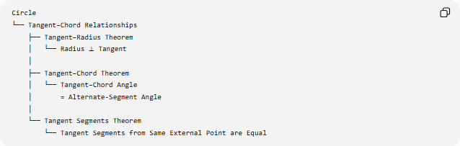
Circle
└── Tangent–Chord Relationships
├── Tangent–Radius Theorem
│ └── Radius ⟂ Tangent
│
├── Tangent–Chord Theorem
│ └── Tangent–Chord Angle
│ = Alternate-Segment Angle
│
└── Tangent Segments Theorem
└── Tangent Segments from Same External Point are Equal

Comparison with Related Theorems
# Source: AI Source: Provided by: [Data Path: Persons Table -> ID Column: 1, Name_En Column: Motasem Essam] -> From: [ChatGPT] on [7/25/2026]
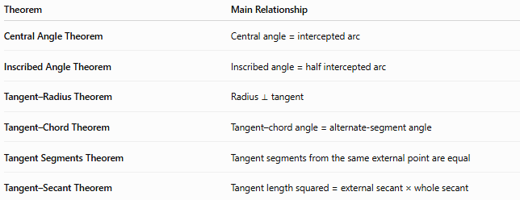
Theorem | Main Relationship
Central Angle Theorem | Central angle = intercepted arc
Inscribed Angle Theorem | Inscribed angle = half intercepted arc
Tangent–Radius Theorem | Radius ⟂ tangent
Tangent–Chord Theorem | Tangent–chord angle = alternate-segment angle
Tangent Segments Theorem | Tangent segments from the same external point are equal
Tangent–Secant Theorem | Tangent length squared = external secant × whole secant

Key Formula Set
# Source: AI Source: Provided by: [Data Path: Persons Table -> ID Column: 1, Name_En Column: Motasem Essam] -> From: [ChatGPT] on [7/25/2026]
For tangent $TA$, chord $AB$, and inscribed angle $∠ACB$:
$$\boxed{m\left(∠TAB\right)=m\left(∠ACB\right)}$$
For the corresponding intercepted arc:
$$\boxed{m\left(∠TAB\right)=\frac{1}{2}m\left(\hat{AB}\right)}$$
For the corresponding central angle:
$$\boxed{m\left(∠TAB\right)=\frac{1}{2}m\left(∠AOB\right)}$$
Therefore:
$$\boxed{m\left(∠TAB\right)=m\left(∠ACB\right)=\frac{1}{2}m\left(\hat{AB}\right)=\frac{1}{2}m\left(∠AOB\right)}$$

Key Points
# Source: AI Source: Provided by: [Data Path: Persons Table -> ID Column: 1, Name_En Column: Motasem Essam] -> From: [ChatGPT] on [7/25/2026]
- The theorem involves one tangent and one chord meeting at the point of tangency.
- The angle between them equals the angle in the alternate segment.
- The chord determines the relevant intercepted arc.
- The tangent–chord angle is half the corresponding central angle.
- It is directly connected to the Inscribed Angle Theorem.
- If the chord is a diameter, the tangent–chord angle is ${90}^{∘}$.
- The theorem is also known as the Alternate Segment Theorem.

Conclusion
# Source: AI Source: Provided by: [Data Path: Persons Table -> ID Column: 1, Name_En Column: Motasem Essam] -> From: [ChatGPT] on [7/25/2026]
The Tangent–Chord Theorem connects three fundamental circle measurements:
$$\boxed{\text{Tangent–Chord Angle}=\text{Inscribed Angle}=\frac{1}{2}\left(\text{Corresponding Arc}\right)}$$
and, equivalently,
$$\boxed{m\left(∠TAB\right)=m\left(∠ACB\right)=\frac{1}{2}m\left(∠AOB\right)}$$
It is one of the principal theorems linking tangents, chords, arcs, central angles, and inscribed angles.

